INTRODUCTION:

PH meter is an scientific instrument that measures the hydrogen ion activity in water-based indicating its alkalinity or acidity in solution.They are often used in pharmaceutical industries and dyeing.

COMPONENTS:

* IC 741 – 4
* IC 7812-2
* IC 7912-2
* 20 K ohm(202) Trimpot-2
* 10K ohm(103)Trimpot-2
* 10K ohm 1/4W CFR -10
* 100K ohm 1/4W CFR-5
* 8 pin IC Base -4
* DOT Board-2
* 1 mfd/25V

ABOUT THE COMPONENTS:

* IC 741 Op-amp

The IC 741 operational amplifier looks like a small chip.The representation of IC 741 op-amp comprises of eight pins.The most significant pins are 2,3 and 6,where pins 2 and 3 denote inverting and non-inverting terminals,and pin 6 denotes output voltage.The triangular form in the IC 741 signifies an op-amp integrated circuit.

* IC 7812 Voltage Regulator:

The IC 7812 is a positive voltage regulator which means that it generates the positive voltage with respect to the common ground.7812 Voltage Regulator is a type of self-contained fixed linear voltage regulator integrated circuit.The IC belongs to IC 79xx voltage regulator family.The 7812 voltage regulator is ease-of-use and available in very low cost.The last two digits 0f 7812 indicates the output voltage that is 12V.

* LM 7912 Negative Voltage Regulator:

LM 7912 belongs to the family of Voltage regulators.The name of “79” indicates negative and the term “12” indicates the voltage.It has constant 12 V output regulator to use as a power or reference voltage for analog and digital circuits.

* 8 Pin IC Base:

An 8 pin IC Base refers to a type of integrated circuit (IC) package that has 8 pins or leads for connecting the IC to a circuit board.These pins are typically arranged in a dual-in line package (DIP) configuration,with two rows of four pins each.8 pin Ics that are widely used in many elecronic devices and appliances,such as timers,oscillators,and digital logic circuits,for example,555 timer IC,LM358 IC,etc….

CIRCUIT DIAGRAM:

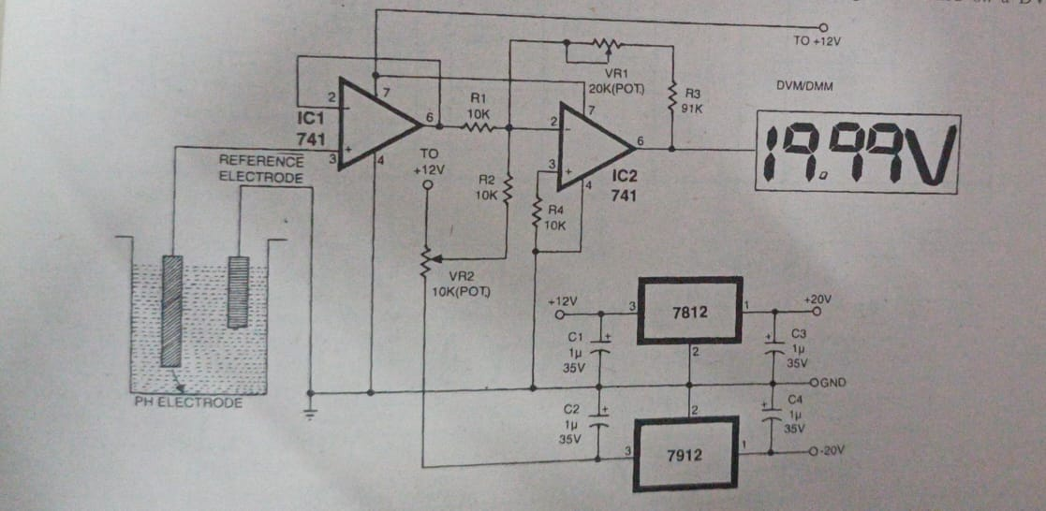

PH METER:

* The term PH is a measure of the degree of acidity or alkalinity in a solution
* The circuit has two op –amp stages in which IC1 is used as a voltage follower,while IC2 is configured as an inverting amplifier,with the gain of 10.
* Pot VR2 is an offset cancellation control.The offset control is adjusted to set output to 7 volts when the input voltage is zero.
* VR1 is a multiturn pot.It is used for calibration of the ph meter.
* For the calibration ,the ph meter electrodes are dipped in a fluid of known ph value,and VR2 is adjusted till a correct reading is obtained on a DVM/DMM.
* The power supply for the circuit is straightforward.It uses regulators of type 7812 and 7912 in standard configuration.

PROJECT DISPLAY:

